**URL:** <https://www.govinfo.gov/>

Use the advanced search option by filtering the search by title or full text (A), entering the keyword (which can be found in *US - keywords for site search.xlsx* file with marked as “Yes”) in (B) and then refining by collection by choosing Acts (public and private laws) as the type of regulation (C).

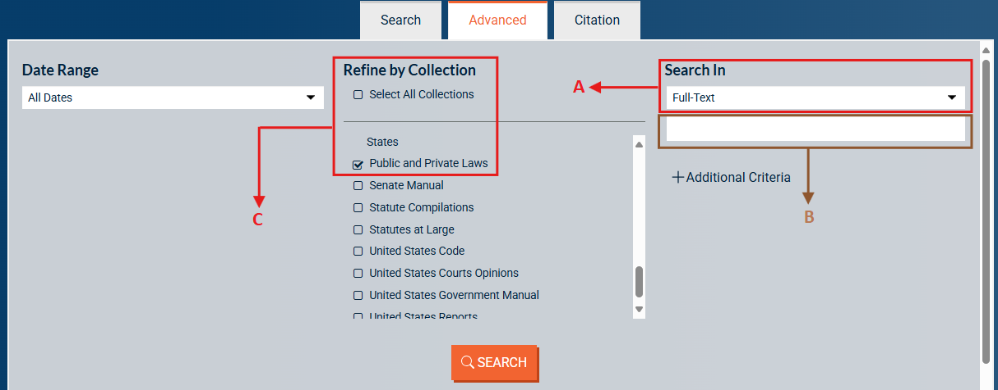

Please take note that there are results in the *Search In* if we enter the keyword and filter it into *Full-Text* (1). However, there are no results if we apply the same term to filter it into *Title* (2). Please find an example below (2nd and 3rd screenshot):

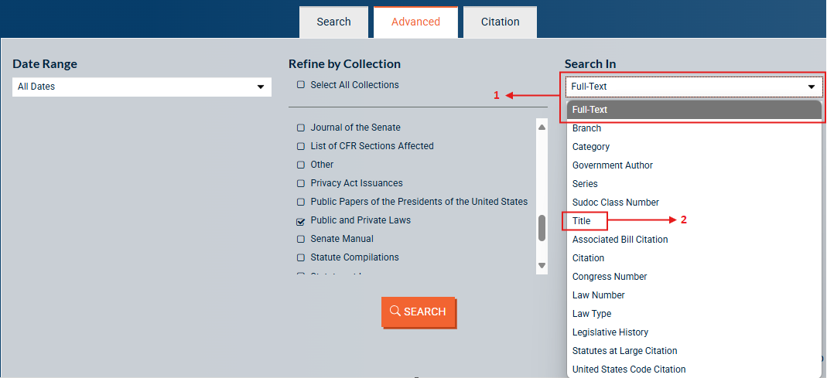

**Full-Text:**

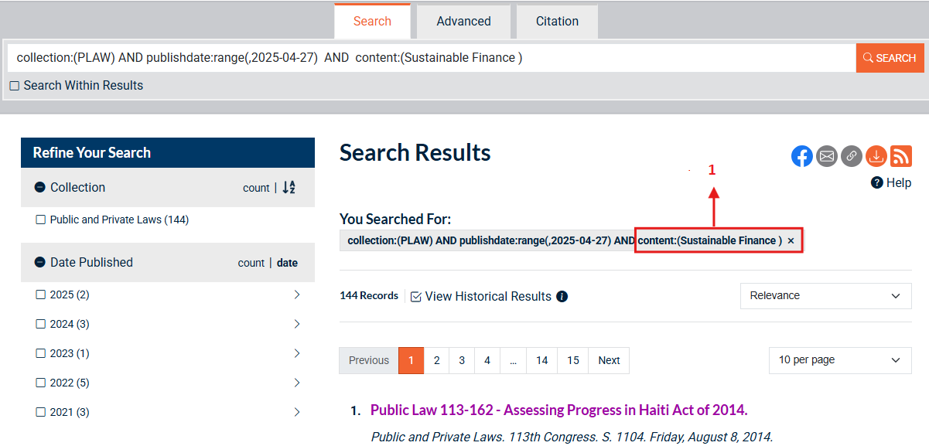

**Title:**

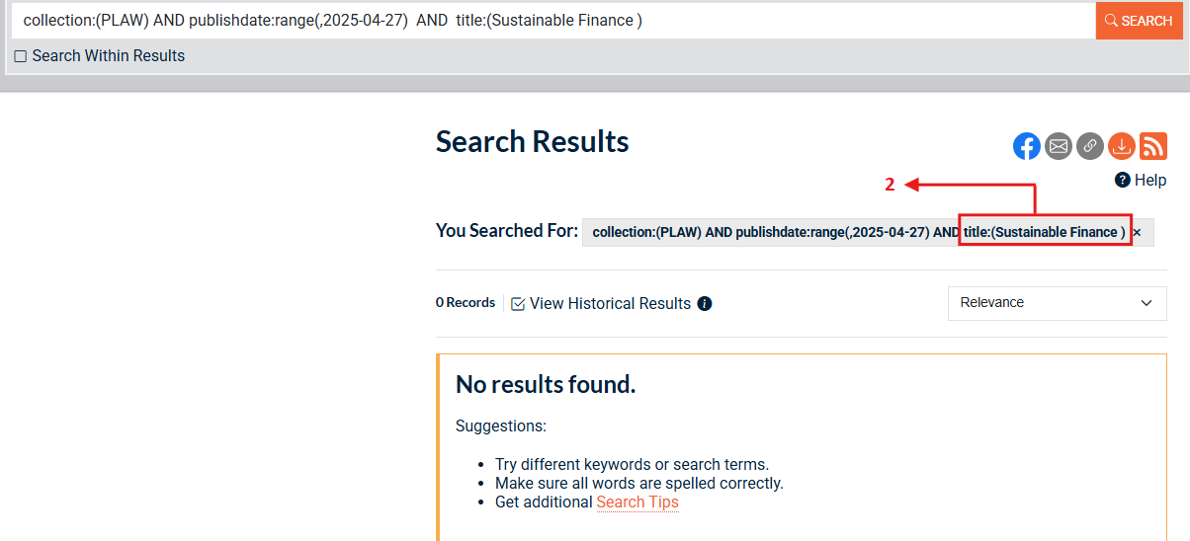

For all the results, extract the necessary metadata as below:

* Red – Original Title and Source Link
* Green – Type of Regulation
* Blue – Date of Adoption
* Purple – Entry into Force Date

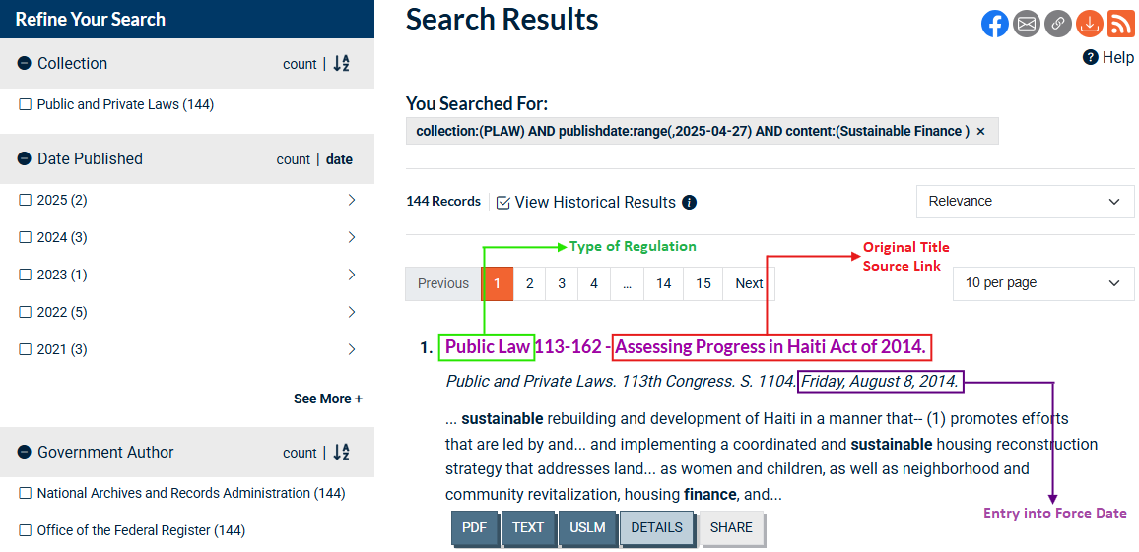

To find the date of adoption, we must navigate to the individual legislation page, which is located at the top of the page under Bill Versions of the Related Documents tab.

